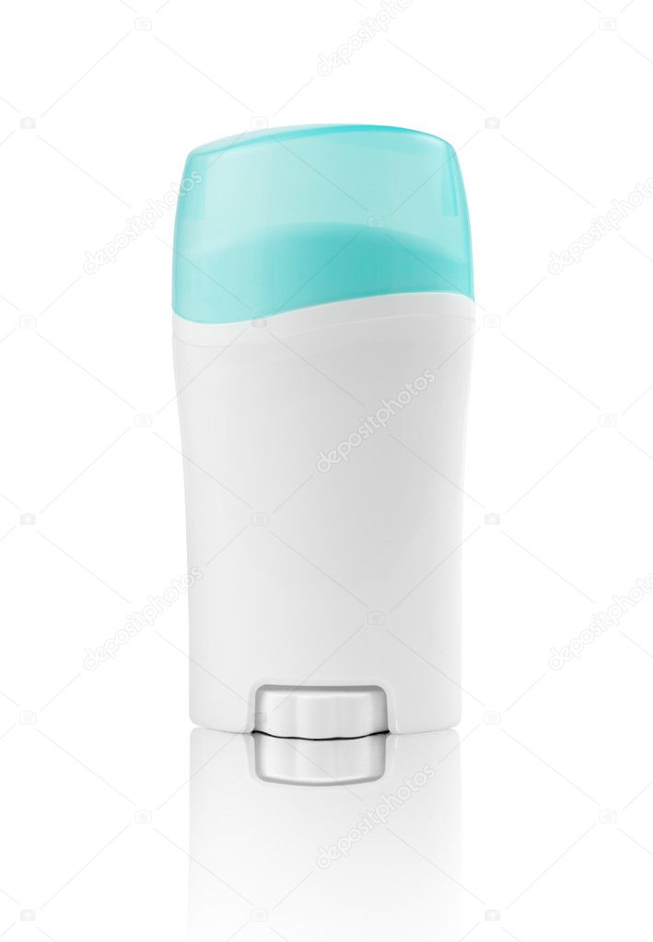**HOW TO GET THE DATE OF YOUR DREAMS WITH THIS ONE TRICK!**

***By simply using Feramodiant never be lonely again!***

Find out why doctors recommend using our deodorant 100% of the time

* **Become popular** - Using Feramodiant takes all the hard work out of making friends.
* 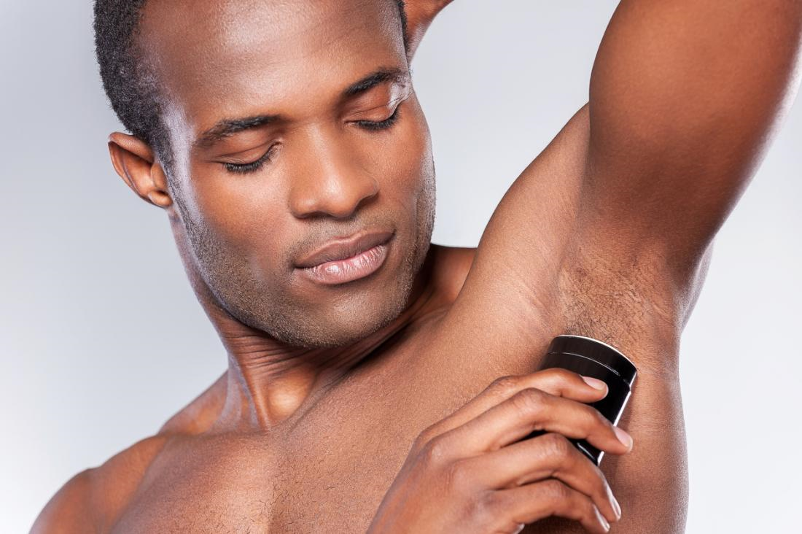**Get the Date** - With Feramodiant your prospective date won’t be able to turn you down!
* **Look attractive 100% of the time** - Studies have shown that smell is a greater indicator of attraction over visual qualities. Feramodiant creates such an alluring smell that it can overcome any unattractive feature.
* **Never have a boring weekend again** - By applying Feramodiant before you go out become the center of attention at any gathering.

**See how using our product made these iconic actors famous**

Wait! Find out more on the next page!

*“After using Feramodiant I have never lost a gig and have starred in countless movies. Feramodiant has also improved my night life tremendously to the point where I can’t go unnoticed by all my lovable adoring fans. I recommend Feramodiant to anyone I can because of its outstanding performance.”* – Brad Pit



*“I never leave the house without a stick of Feramodiant. Who could? It makes my day so easy meeting with clients, signing deals, and whatever else may surprise me during the day. It truly is a miracle product! I can always feel confident that my day will go well with Feramodiant”*

– Jessica Alba

*“Of course, I use Feramodiant, are you kidding me? Using Feramodiant is the secret to my success. How could I not use it? I love the product! I use it every time I meet someone new or try to pitch an idea. Works every time. In fact, I wouldn’t be the big star I am today without it!”*

– Ryan Reynolds

**Avoid the tedium of using alternative methods**

Feramodiant Costs **only $19.97** for a single bar! Other solutions like dating websites force you to pay monthly fees upwards of $50 and or require you to compromise your precious personal data. On top of that you need to constantly check on updates and weed out those you don’t want to date. You can **get around all that hassle** by simply buying a stick of Feramodiant.

**Order now and get access to these 3-free easy to use perks**

* **Anti-stink sweat repellant** – Use this to ensure that your new smell doesn’t compete with your old smell.
* **Super hydrator bottle** – Ensure that your mouth never goes dry after meeting your significant other with our Super hydrator bottle. This bottle contains an infinite supply of fresh cold spring water that super hydrates your body after **only one sip**!
* **Ferra-Hairgel** – Everyone loves a good-looking hair style along with an attractive smell. If you order Feramodiant now receive a free bottle of our patented Ferra-Hairgel. This gel will never droop, smudge, or fade preserving your hair for all the new glamor shots you’ll be taking.

**Not Convinced? No worries!**

****We offer a **100% money back guarantee** no questions asked. If you don’t love our product we will not hesitate to make things right, **for you our valued customer**. No need to worry about return shipping either! If you don’t love our product not only will we refund you, we will let you keep the product at **no extra cost.**

**Buy now!**

Only 100 sticks exist so get yours now! Supplies are limited so call us at 1-800-FERA-MOD and get yours today!

Colin Hite

- Colin Hite

P.S. Remember, smell is the make or break moment in any first impression. Never lose that chance by using Feramodiant before you go out.

P.P.S. Don’t forget that using Feramodiant will make you the talk of the town with no hassle, so you can be whoever you want to be. Order now!